Winter-Spring 2019-20 Events at Holy Spirit
(in addition to regularly scheduled Sunday & weekday Masses)

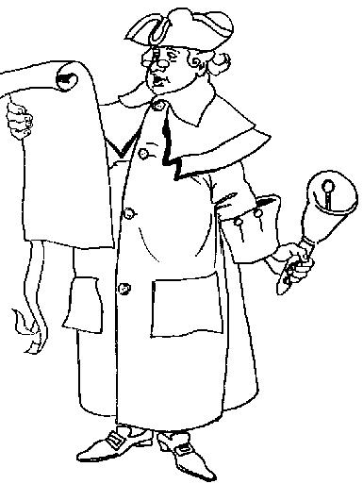
12/11: 6:15 pm – Advent Taizé service
12/15: Post-Mass Christmas Potluck
12/24: 7:00 pm – Christ Mass
12/25: 10:00 am – Christmas Day Mass
12/29: Post-Mass Movie: The Gospel of Mark (21 minutes)
01/03: 1:15 – Yoga
01/05: Post-Mass Movie: The Gospel of Matthew (10 minutes)
01/08: 6:15 pm – Epiphany Taizé service
01/10: 1:15 – Yoga
01/11: 5 pm – Saturday Mass
01/12: Post-Mass Movie: The Gospel of Luke & Acts (15 minutes)
01/17: 1:15 – Yoga
01/22: 6:15 pm – Final Winter Taizé service
01/24: 1:15 – Yoga
01/26: Post-Mass Movie: The Gospel of John (10 minutes)
01/29: 6 pm – Coffee, Tea, & Short Reads: C.S. Lewis’ The Great Divorce (Dinner provided)
01/31: 1:15 – Yoga
02/08: 5 pm – Saturday Mass
02/09: Post-Mass coffee hour presentation by Professor Stephanie Larson on refugees
02/14: 6 pm – Winter Bible Study 1 – The Catholic Epistles: James (Dinner provided)
02/26: Noon and 6 pm – Ash Wednesday Mass
02/28: 6 pm – Winter Bible Study 2 – The Catholic Epistles: 1 & 2 Peter (Dinner provided)
03/06: 5:45 pm – Stations of the Cross/ 6:30 – Lenten Program (Bartimaeus)
03/07: 9 am – 2 pm – Lenten Baking Retreat with Fr. Joseph Harmon
03/12: 6 pm – Winter Bible Study 3 – The Catholic Epistles: 1, 2, & 3 John; Jude (Dinner provided)
03/13: 5:45 pm – Stations of the Cross/6:30 – Lenten Program (The Rich Young Man)
03/14: 5 pm – Saturday Mass
03/20: 5:45 pm – Stations of the Cross/6:30 – Lenten Program (The Calling of Matthew)
03/27: 5:45 pm – Stations of the Cross/6:30 – Lenten Program (Jonah)
04/02: 6 pm – Coffee, Tea, & Short Reads: Mark Salzman, Lying Awake (Dinner provided)
04/03: 5:45 pm – Stations of the Cross/6:30 – Lenten Program (The Woman at the Well)
04/09: 7 pm – Holy Thursday Mass
Gethsemane Vigil until midnight
04/10: Noon – Good Friday service
04/11: 7 pm – The Great Easter Vigil
04/12: 10:15 am – Easter Day Mass

