Winter 2019-20 Events at Holy Spirit

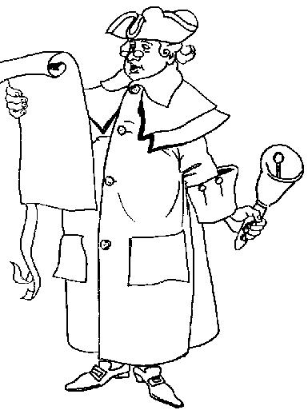
12/11: 6:15 pm – Advent Taizé service
12/15: Post-Mass Christmas Potluck
12/24: 7:00 pm – Christ Mass
12/25: 10:00 am – Christmas Day Mass
12/29: Post-Mass Movie: The Gospel of Mark (21 minutes)
01/08: 6:15 pm – Epiphany Taizé service
01/03: 1:15 – Yoga
01/05: Post-Mass Movie: The Gospel of Matthew (10 minutes)
01/10: 1:15 - Yoga
01/12: Post-Mass Movie: The Gospel of Luke & Acts (15 minutes)
01/17: 1:15 – Yoga
01/22: 6:15 pm – Final Winter Taizé service
01/24: 1:15 – Yoga
01/26: Post-Mass Movie: The Gospel of John (15 minutes)
01/29: 6 pm – Coffee, Tea, & Short Reads: C.S. Lewis’ The Great Divorce
(Dinner provided)
01/31: 1:15 – Yoga
02/14: 6 pm – Winter Bible Study 1 – The Catholic Epistles: James (Dinner)
02/26: Noon and 6 pm – Ash Wednesday Mass
02/28: 6 pm – Winter Bible Study 2 – The Catholic Epistles: 1 & 2 Peter (Dinner)
03/06: 6 pm – Stations of the Cross (and every Friday until 04/03)
03/07: 10 am – 2 pm – Lenten Retreat with Fr. Joseph Harmon
03/13: 6 pm – Winter Bible Study 3 – The Catholic Epistles: 1, 2, & 3 John; Jude (Dinner)

